

Cross Words

Monthly Newsletter of Cross Ev. Lutheran Church

August 2013 Volume 13, Issue 8

Sing God’s Truth

*We might call something our favorite song because it has a catchy tune and it is easy to sing along to it. It might remind us of a special person or event. It might have a powerful message with which we agree.*

*What makes a hymn a “favorite hymn”? A catchy tune? That is true of many hymns. But some hymns are not always that easy to sing, but that alright, when it comes to praising the Lord, He is certainly worth the extra effort. Maybe they remind us of a special person, for example, a hymn sung at a funeral. But first and foremost, we want hymns to remind us of our God. Yes, we want our favorite hymn to proclaim a powerful message, a truth from God’s Word. For the next eight month’s, under the theme* ***Sing God’s Truth,***  *we shall consider some favorite, well-known hymns that proclaim important truth’s from the Scriptures about our Savior. May it serve as a reminder to us that our favorite hymns are not just “songs”, but a means for praise and proclamation.*

**“Savior of the Nations, Come”**

*Jesus, Human and Divine*

# *“So the holy one to be born will be called the Son of God” (Luke 1:35).*

When the angel Gabriel announced to Mary that she would conceive and have a son, the young woman identified a flaw in the messenger’s statement. “How will this be,” she asked, “since I am a virgin?” (verse 34). The angel’s words defied all logic and all natural laws. At no time in history has any other woman conceived and given birth to a child without the benefit of a human father. The rules of nature insist that it cannot happen. It is indeed a paradox, but one that God could easily overcome (Luke 1:37).

Yet this was not the greatest paradox facing the young virgin. As she contemplated this miracle birth, she wondered how her human child could be God’s Son, a *divine* child born to a *human* mother. Jesus would be the Savior long promised by the Lord’s prophets. Less than a century later, the writer to the Hebrews would explain why it was necessary for God to become flesh. Jesus shared our humanity “so that by his death he might destroy him who holds the power of death—that is, the devil—and free those who all their lives were held in slavery by their fear of death” (2:14,15). Jesus: God born in Bethlehem! What a miracle! What a comfort! Jesus is both fully human and fully divine, our perfect Savior and the Savior of all nations.

This wonderful event has been the subject of many Christian hymns over the centuries. One especially well stated is the fourth-century hymn “Savior of the Nations, Come” (CW 2), written by the chief poet of the early church, St. Ambrose (340–397). Ambrose sang God’s truth originally in eight Latin stanzas. Martin Luther wanted to join him, so he later translated it into German verse. This Advent hymn has long been recognized as one of the great hymns of Christendom.

The hymn begins with the earnest plea of believers who recognize their desperate need for a divine Savior from sin and death: “Savior of the nations, come”(st. 1). Christian faith over the centuries has sung, “Wondrous birth! O wondrous Child of the virgin undefiled” (st. 3). Like all Christians we rejoice in what God has done for us in Jesus. We raise our voices and spirits and joyfully join the eternal hymn of praise to the Father, Son, and Holy Spirit (st. 5).

Our Christian faith erupts in song because our Savior is both human and divine!

© 2007 Northwestern Publishing House. All rights reserved.



**VACATION BIBLE SCHOOL**

**August 12, 13,14**

**9:00 am - 4:00 pm**

**Preschool through 6th Grade**

**763-477-5292**

[**www.crosslutheranwels.org**](http://www.crosslutheranwels.org)

**Sign up at church or online**

***Luther on the 6th Commandment***

*(The following is the second of a series of articles concerning the 6th Commandment by Pastor Tim Learman of Trinity Lutheran Church in Lake City, MN They apply what God’s Word says about morality and marriage to current issues in our state and nation. May the Lord gives us the wisdom and desire to apply His holy will to our lives.)*

***Luther on the 6th Commandment***

Let us therefore first of all note carefully how very highly God honors and extols married life by giving it His sanction and protection in the Ten Commandments. He sanctioned it earlier in the Fourth Commandment, “You shall honor your father and mother.” But here, as I said, he safeguards and protects it. Therefore he wants to see it honored, upheld, and treated also by us as being divinely instituted and full of blessing. For He established it as the first one of all His institutions, and He created man and woman with obvious differences, not for wickedness, but that they may be and remain attracted to each other, be fruitful, have children, care for them, and bring them up to the glory of God.

(Luther’s Large Catechism. CPH, Saint Louis, MO)

Those who are against homosexuality are often labeled as haters or bigots. At times some *are* violent, mean or cruel to those engaged in this lifestyle. However, as a Christian who recognizes the life of chastity that the Lord has called us to, we are to be just the opposite of a hater. God calls us *to love*. “We love because he first loved us.” (1 John 4:19)

Many feel that loving means you except some and their actions or lifestyle, just how they are. They feel to speak against someone else’s actions is not kind or accepting. Sharing God’s condemnation of certain sins is viewed as cruel and unloving in today’s society influenced so heavily by sin and unbelief. Speaking against a particular sin someone is caught up in and unrepentant for might very well upset them. It may even damage the relationship between the sinner and the one calling to repentance. Still, to ignore or brush aside the sin is far more unloving.

We have probably seen others who don’t care. It might be a parent who just allows the teenage son to do whatever he wants, no instruction, no discipline, no correction. Maybe an employer sits by idly watching a worker fail. He gives no suggestions for improvement, no encouragement for a job well done, no corrections for work done incorrectly. He figures he will just fire and replace the employee. These situations show failures to care and love. So also with the unrepentant sinner caught up in homosexuality. To *not* warn of the dangers of the sin and unrepentance is a lack of Christian love.

We are called by God to bring each other to repentance. Whether the sin is cursing and swearing, greed, adultery, dishonoring of the Word or homosexuality, when someone continues in the sin without repenting, we must call those within our faith to repent. Many say that Jesus only preached “love.” That is true. His loving message also included, “The kingdom of God is near. Repent and believe the good news!” (Mark 1:15) A message and of love must include repentance and the forgiveness of sins.

In the Gospel of John Jesus told his disciples, “Greater love has no on than this, that he lay down his life for his friends.” Jesus did this to make a payment for our sin for forgiveness and eternal life. “He is the atoning sacrifice for our sins . . . also for the sins of the whole world.” (1 John 2:2) With this great gift given to us that cost our Lord everything, but us nothing, why would we reject it? Hebrews 10:26 warns of this, “If we deliberately keep on sinning after we have received the knowledge of the truth, no sacrifice for sins is left, but only a fearful expectation of judgment and of raging fire that will consume the enemies of God.”

Last November there was an opportunity to vote on a marriage amendment to the Minnesota constitution defining more clearly that marriage is between one man and one woman. Some questioned whether it was necessary or if change would be passed. Rulings for gay marriage passed by individual judges in other states show some of the dangers in our society. While there is blessing to be found in the separation of Church and State, marriage (an institution set up by God) is also governed by the state (for the benefit and protection of spouses). There is then a necessary interworking on the institution of marriage in our country. Voting for the change was an opportunity for Christians to confess their faith and declare God’s condemnation of the sin.

Just voting, however, in not doing all we can. We need to continue to share Christ’s message of repentance and forgiveness for all sins. We need to impress upon all that each person is a precious soul loved by God. When we see a desire to leave the sin and battle its temptations we have the joy, privilege and duty to announce, “Dear child, your sins are forgiven. Jesus’ death on the cross paid for your sin as well.”

**August Church Council Meeting**

The August Church Council Meeting will be Thursday, August 8 at 6:30pm. This is our annual Picnic/Cook-Out Meeting. We will be gathering at the palatial James Reader estate (6200 Rolling Hills Road, Corcoran)

**SENIOR FELLOWSHIP**

[](http://en.wikipedia.org/wiki/File:Clemens_Gardens.JPG)

On Thursday, August 15, we will go visit the Munsinger Gardens in St Cloud.(This trip was rescheduled from July because of hot weather) We will also be “doing lunch” at Coyote Moon We will car pool. Watch for information in bulletin.

**“19 Minute” Bible Study**

Sundays,

In the Sanctuary

C:\Users\church office\AppData\Local\Microsoft\Windows\Temporary Internet Files\Content.IE5\8N4YF2EJ\MC900383112[1].wmf

10:20 am

(June 2 thru August 25)

Grand Themes

& Key Words of the Bible

**WEST LUTHERAN GOLF TOURNAMENT**

Monday, August 5, West Lutheran High School hold its annual Golf Tournament at Wild March in Buffalo. Cost $90 – golf, cart, supper & prizes (includes $20 donation towards West Lutheran High School Athletic Department. Registration forms are in the back of the church.



**NATIONAL NIGHT OUT**

The Evangelism Committee is again hosting a booth at Rockford’s celebration of ***NATIONAL NIGHT OUT***, ***on Tuesday, Aug 5th from 6:00 pm to 7:30 pm.*** We will be setting up at around 4:30 pm. We will be handing out coloring material for kids, as well as fliers for our VBS and have information on our church. A sign-up sheet is posted for those who would like to come and help staff the booth.

**C:\Users\church office\AppData\Local\Microsoft\Windows\Temporary Internet Files\Content.IE5\4M9S0069\MC900391134[1].wmf**

**MEN’S BREAKFAST BIBLE STUDY**

*Saturday, August 17 is the date for the August edition of the Men’s Breakfast Bible Study. On the menu to feed our souls will be Daniel 3. On the menu to feed our bodies will be waffles. Men, make plans to attend!!!!*

**C:\Users\church office\AppData\Local\Microsoft\Windows\Temporary Internet Files\Content.IE5\4M9S0069\MC900078817[1].wmf**

**RIVER DAYS PARADE**

Cross will again have a float in the River Days Parade on Sunday, Aug.11. If you would like to walk along with the float to help pass out water and fliers, come to the Rockford Mall parking lot by 11:45 am.

MC900048041[1]

**SUNDAY SCHOOL TEACHERS**

The Sunday School teachers will have their first meeting of the 2013-14 year on Monday, Aug 26 at 7:00 pm.

**MC900023662[1]**

**WORSHIP COMMITTEE**

The Worship Committee will meet on Monday, Aug 19 to review tentative worship plans for the fall and winter on Monday, Aug 19th at 7:00 pm.

**CROSS LIGHTS**

*Cross LIGHTS will resume meeting on Tuesday, Aug 5th at 7:30 pm. All the women of the congregation are invited to attend. You don’t have to be a member to attend.*

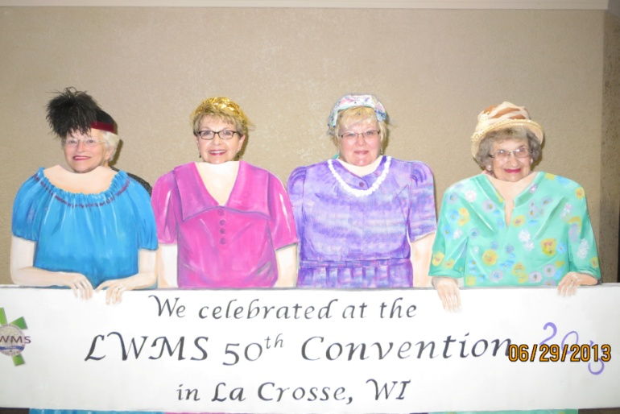

**Our ladies at the LWMS National Convention**